Educational Materials Toolkit for Schools
Material | Last Updated
WA Required Immunizations for School  - 2024-2025  - 2025-2026 | December 2023  December 2024
WA Immunization Schedule  Recommended Adolescent Imm. Schedule (ages 9-18) – English / Spanish | March 2023 | 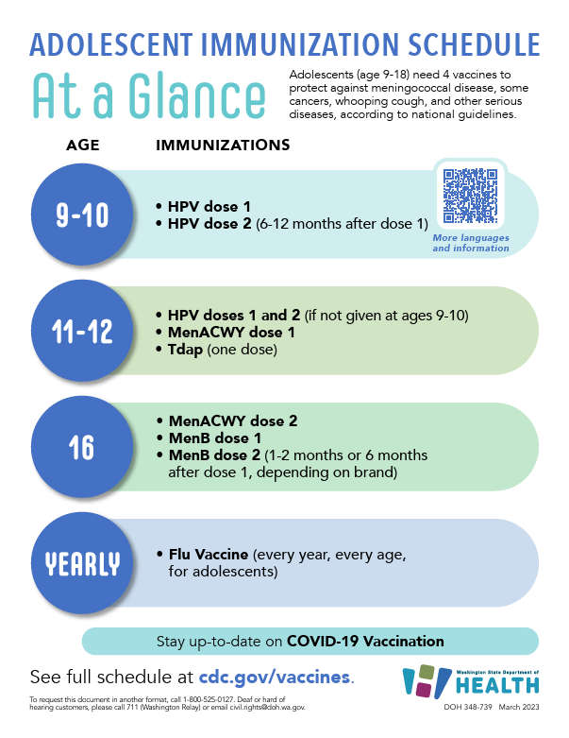
WA Immunization Schedule (CDC)  2025 Recommended Immunizations for Birth – 6 yrs old.  English / Spanish | November 2024 | 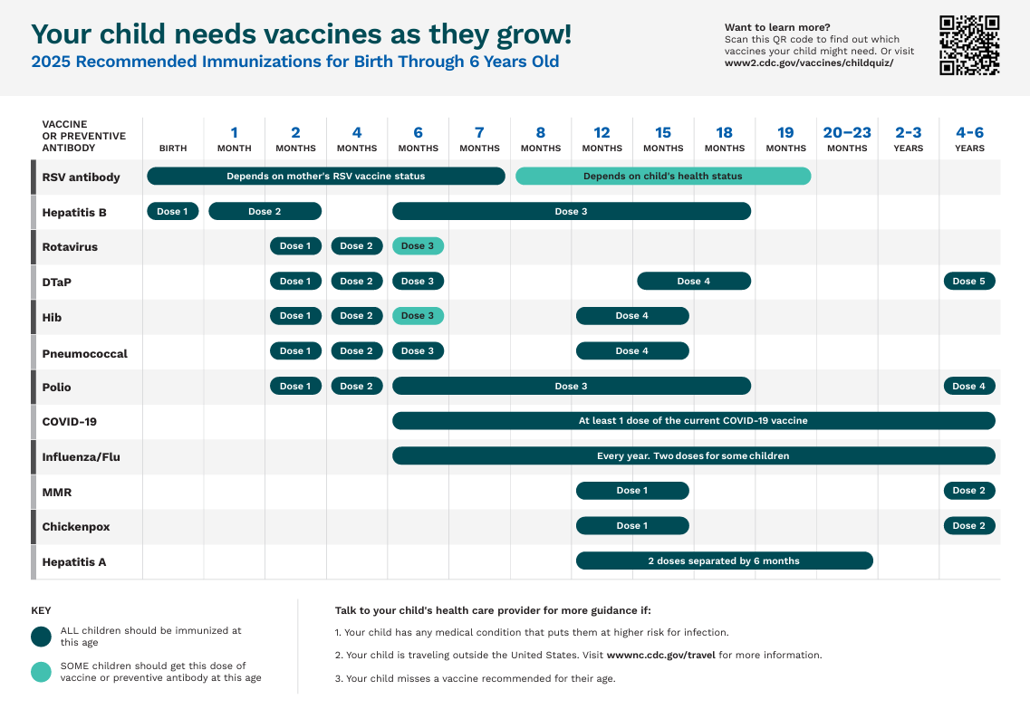
Brochure – Protect Your Family from the Flu  English / Spanish | September 2023 | 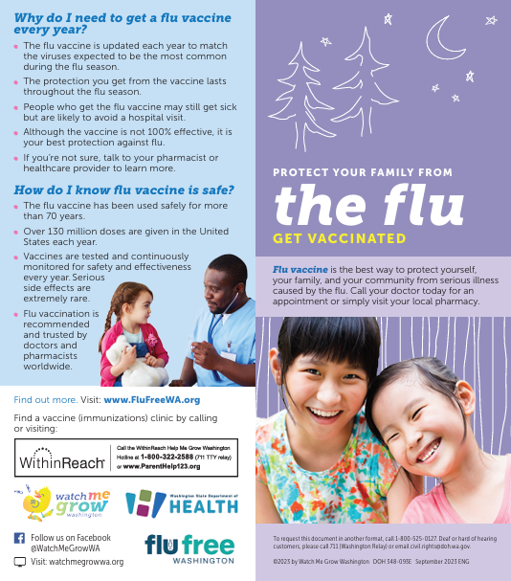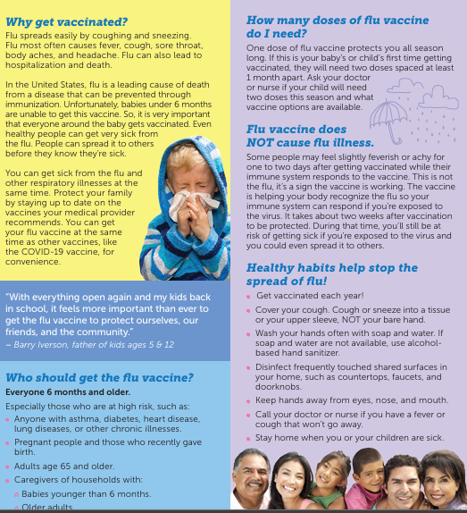
Flyer from Immunize.org – Communicating the Benefits of Influenza Vaccination  English | September 2024 | 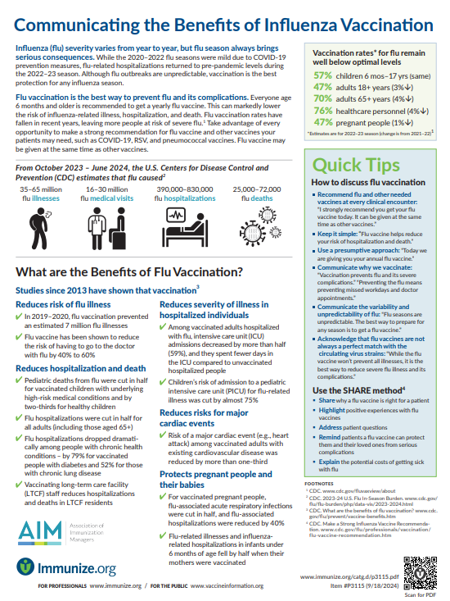
Handout packet from Immunize.org – Evidence Shows Vaccines Unrelated to Autism (3 pages)  English | January 21, 2024 | 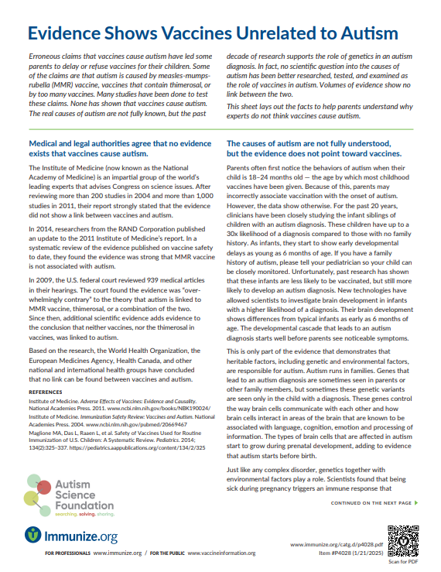
WA DOH Parent Immunization Reminder Letter  English | March 2025 | 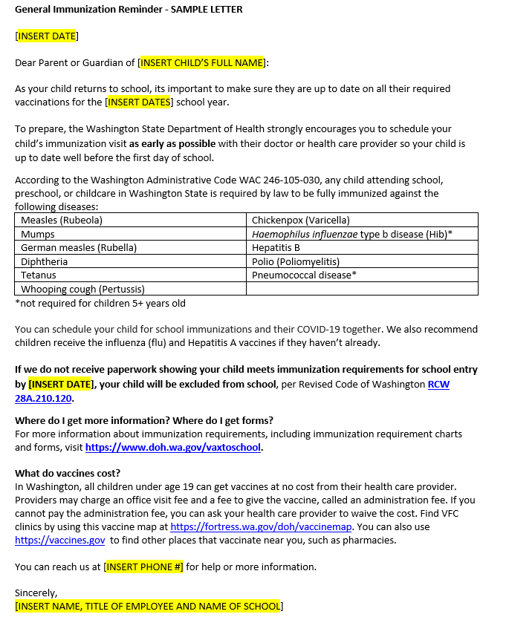
Flu Free WA Toolkit
Partner Toolkit

CDC Webpage – Flu Vaccine Safety  Spanish | August 2023
Immunize.org Webpage  Ask the Experts |  | Ask the Experts is a popular destination for healthcare professionals. Experts provide clear, easy-to-understand answers to commonly asked questions about vaccines and their use.
WA DOH Webpage – Flu Facts  English / Spanish | Updated often
WA DOH Webpage – Childhood Vaccine Campaign Toolkit  English webpage | March 2023 | Contains promotional materials (flyer, social media, school letter for parents, and backpack stuffer)
WA DOH Webpage – Childhood Immunizations are Important  English Webpage |  | Facts and FAQs
WA DOH Webpage – Family Friendly Vaccine Requirements Page  English / Spanish |  | Contains Immunization charts, links to CDC webpages for specific diseases, exemption forms, and certificate of immunization status forms.

